Day 19 - 11th Aug 2026

Task 1:
What are wrapper class?
10.40 to 10.41

Task 2:
What do you understand by auto boxing and unboxing?
10.42 to 10.45

Task 3:
Can you create a program to show the use of wrapper classes
11.00 to 11.05

Eg:
// Autoboxing: primitive to wrapper
int primitiveInt = 10;
Integer wrappedInt = primitiveInt; // compiler converts automatically

Integer objInt = new Integer(25); // explicit wrapper object
int unboxedInt = objInt; // compiler converts automatically

TASK 4:
Where do we use wrapper classes?
11.06 to 11.08

Task 5:
Can you create a program to show the difference between abstraction and encapsulation
11.09 to 11.18

TSK 6:
What is executor framework in Java 5?why do we use? Where do we use?
11.19 to 11.23

Task 7:
Can you explain.. Executor, executor service and executors?
With sample progrm
11.24 to 11.28

Task 8:
When do we use callable interface with future?

11.29 to 11.35

Task 9:
how do we create ExecutorService, Submit Tasks, Manage Results and Shutdown Executor.
Can you explain the flow
11.36 to 11.40

Task 10:

Can you create programs which uses the concepts of character input output in file handling and buffer input output in file handling?
11.41 to 11.48

Task 11:

What is an Object class?
Why do we use them?
Can you show me the diagramatic representation of object with other classes.
11.49 to 11.52

Task 12:
Can you display the methods in Object class
11.53 to 11.57

Task 13:
What are generics ? benefits of generics .. can you explain wit a code .
11.58 to 12.02

Java 8 features 👍

Task 14:

- Explain why lambda expressions were introduced in Java 8.
- What is a functional interface? Give two examples from the Java API.
- Differentiate between Streams and Collections.
- What problem does the Optional class solve?
- Why were default methods added to interfaces in Java 8?
- What are method references and how do they improve readability?
- Describe the improvements in the Date-Time API compared to java.util.Date.
- How does the Base64 API simplify encoding/decoding tasks?
- Give a real-world example where static methods in interfaces are useful.
Till 3pm

Task 15:
Whats going on in this code snippet? Can you check .. can you imagine a traditional code for performing the same.
public record Customer(String name, int age) {}

public class RecordDemo {
public static void main(String[] args) {
Customer c = new Customer("Prasunamba", 30);
System.out.println(c.name()); // Prasunamba
System.out.println(c); // Customer[name=Prasunamba, age=30]
}
}

Task 16:
Can you extend this code for creating a fd child class.. Will it work? If not whats stopping to extend fd from Transaction..
java
public sealed class Transaction permits Credit, Debit {}
final class Credit extends Transaction {}
final class Debit extends Transaction {}

Task 17:
Can I write a switch case.. Like this also?... my traditional switch case is now parsing heterogeneous data??????????????????????????????? How ???

static void process(Object obj) {
switch (obj) {
case String s -> System.out.println("String: " + s.toUpperCase());
case Integer i -> System.out.println("Integer x10: " + i * 10);
default -> System.out.println("Unknown type");
}
}
Task 18:
We dont know what threads do internally… \
And now these imaginary threads????????????????

Whats nonsense ? in this code..

import java.util.concurrent.Executors;

public class VirtualThreadDemo {
public static void main(String[] args) {
try (var executor = Executors.newVirtualThreadPerTaskExecutor()) {
executor.submit(() -> System.out.println("Running on virtual thread"));
}
}
}

Task 19:
- What is a code smell and how does it differ from a bug or error?
- Why are code smells considered indicators of deeper design problems?
- How do code smells affect maintainability, scalability, and readability of software?
- Can you explain the difference between Long Method and Large Class smells?
- How does Duplicated Code impact future development and bug fixing?

%%%%%%%%%%%%%%%%%%%%%%%%%%%%%%%%%%%%%%%%%%%%%%%%%%%%%%%%%%%%%%%%%%%%%%%%%%%%%%%%%%%%%%%%%%%%%%
Home Task
%%%%%%%%%%%%%%%%%%%%%%%%%%%%%%%%%%%%%%%%%%%%%%%%%%%%%%%%%%%%%%%%%%%%%%%%%%%%%%%%%%%%%%%%%%%%%%
Task 1
Create a Mini Banking App project using Java 8 features.

Project structure can be like this .. juz for ref only.. You can create in your own style..

Code
BankingDemo/
├── src/
│ └── com/bank/demo/
│ ├── Customer.java
│ ├── Transaction.java
│ ├── Payment.java
│ ├── CreditCardPayment.java
│ └── BankingApp.java
└── README.md

package com.bank.demo;

import java.time.LocalDate;
import java.util.*;
import java.util.stream.Collectors;

public class BankingApp {
public static void main(String[] args) {
// 1. Transactions with Streams + Lambdas
List<Transaction> transactions = Arrays.asList(
new Transaction(500, LocalDate.now()),
new Transaction(2500, LocalDate.now()),
new Transaction(1200, LocalDate.now())
);

List<Transaction> highValue = transactions.stream()
.filter(t -> t.getAmount() > 1000)
.collect(Collectors.toList());

highValue.forEach(t -> System.out.println("High Value Txn: " + t.getAmount()));

// 2. Optional for Customer PAN
Customer c1 = new Customer("Ravi", null);
c1.getPanCard().ifPresentOrElse(
val -> System.out.println("PAN: " + val),
() -> System.out.println("PAN not available")
);

// 3. Date-Time API for EMI scheduling
LocalDate today = LocalDate.now();
LocalDate nextEmi = today.plusMonths(1);
System.out.println("Next EMI due on: " + nextEmi);

// 4. Default Methods in Interfaces
Payment p = new CreditCardPayment();
p.validate();
Payment.log("Payment processed successfully");

// 5. Method References for Logging
List<String> logs = Arrays.asList("Debit", "Credit", "Transfer");
logs.forEach(System.out::println);
}
}
Credit card payment.java

package com.bank.demo;

public class CreditCardPayment implements Payment {
// inherits default validate() method
}

Customer.java
package com.bank.demo;

import java.util.Optional;

public class Customer {
private String name;
private Optional<String> panCard; // may be missing

public Customer(String name, String panCard) {
this.name = name;
this.panCard = Optional.ofNullable(panCard);
}

public String getName() {
return name;
}

public Optional<String> getPanCard() {
return panCard;
}
}

Payment.java
package com.bank.demo;

public interface Payment {
default void validate() {
System.out.println("Basic validation done.");
}

static void log(String msg) {
System.out.println("LOG: " + msg);
}
}

Transaction.java

package com.bank.demo;

import java.time.LocalDate;

public class Transaction {
int amount;
LocalDate date;

public Transaction(int amount, LocalDate date) {
this.amount = amount;
this.date = date;
}

public int getAmount() {
return amount;
}

public LocalDate getDate() {
return date;
}
}

compile it

re\MiniBankingApplication> javac src/com/bank/demo/*.java

Run it
java -cp src com.bank.demo.BankingApp

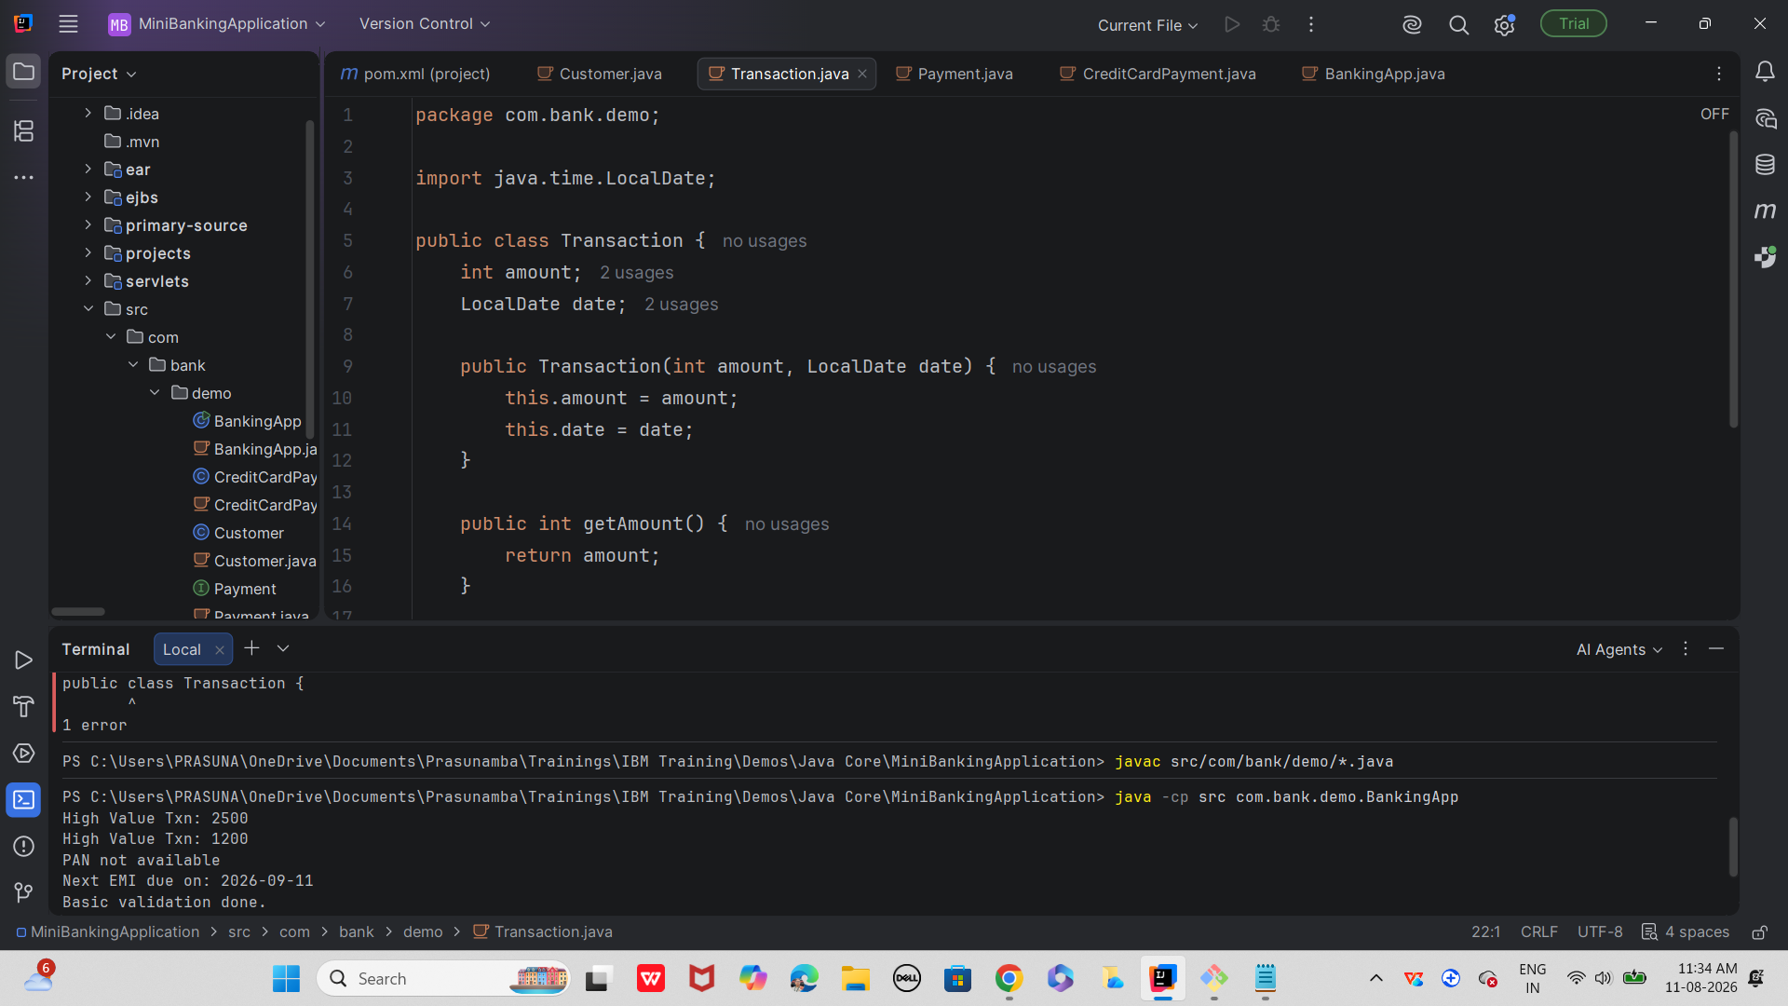

000000000000000000000000000000000000000000000000000000000000000000000000000000000000000000000000000000000000000000000000

Task 2

Create a Mini Banking App project using Java 17 n 21 features.

ode
banking-app/
├── src/
│ ├── main/
│ │ ├── java/
│ │ │ └── com/bank/
│ │ │ ├── model/
│ │ │ │ ├── Customer.java
│ │ │ │ ├── Transaction.java
│ │ │ │ ├── Credit.java
│ │ │ │ ├── Debit.java
│ │ │ │ └── Transfer.java
│ │ │ ├── service/
│ │ │ │ └── BankService.java
│ │ │ ├── processor/
│ │ │ │ └── TransactionProcessor.java
│ │ │ └── App.java
└── pom.xml (if using Maven)

